EJC EXAMPLE 6
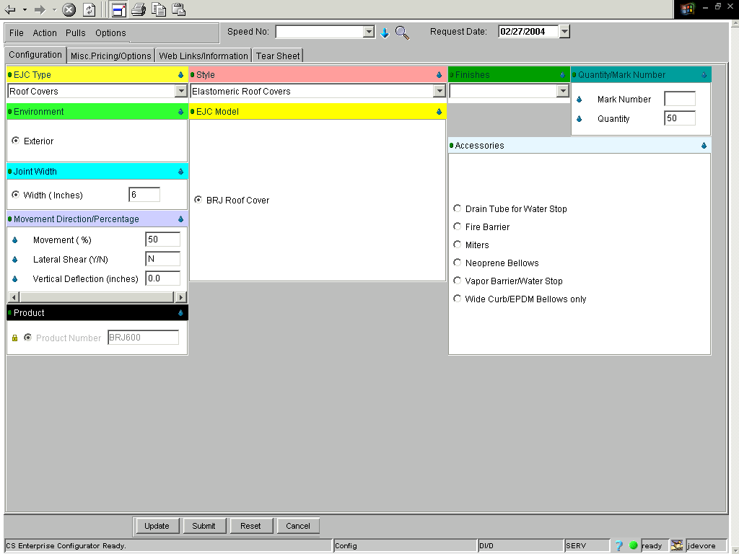
Click File, Save Current and Create New.
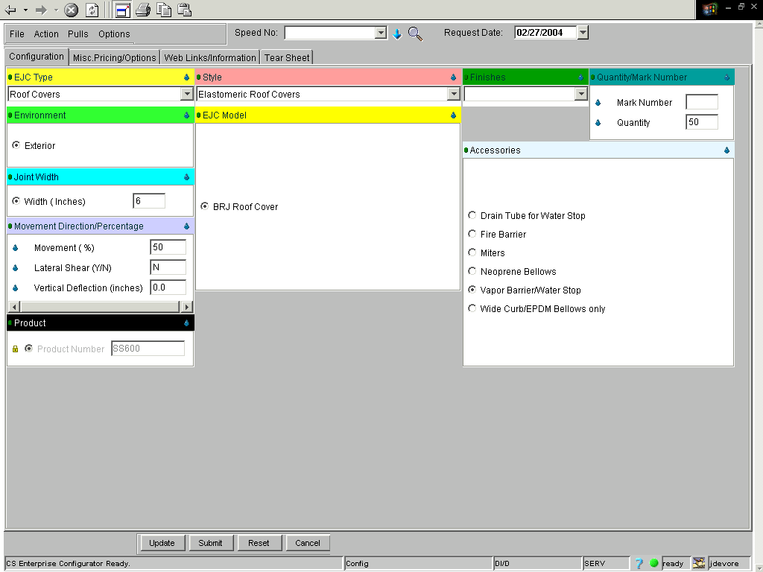
If done correctly, your price will equal $1,858.10.

